The argument that “[a little semantics goes a long way](https://www.cs.rpi.edu/~hendler/LittleSemanticsWeb.html)”[1] is sometimes misrepresented as being against data standards, instead of being about assessing semantic annotation by the improvement in interoperability with what is annotated. It remains all the more puzzling to many working in Knowledge Networks, because it quotes James Hendler, the author of the original “semantic Web” paper, and editor of the field’s reference textbook [2]. Until recently, this confusion reflected an argument between Knowledge Engineering (declarative) and the Science of the Web[3] (executable). However, the use of AI to annotate data elements pushes us to the shores of a new world, where annotations are made and acted upon by AI engines and researchers alike, configured to identify multiparametric signals defining association manifolds.

### Own your own relationships

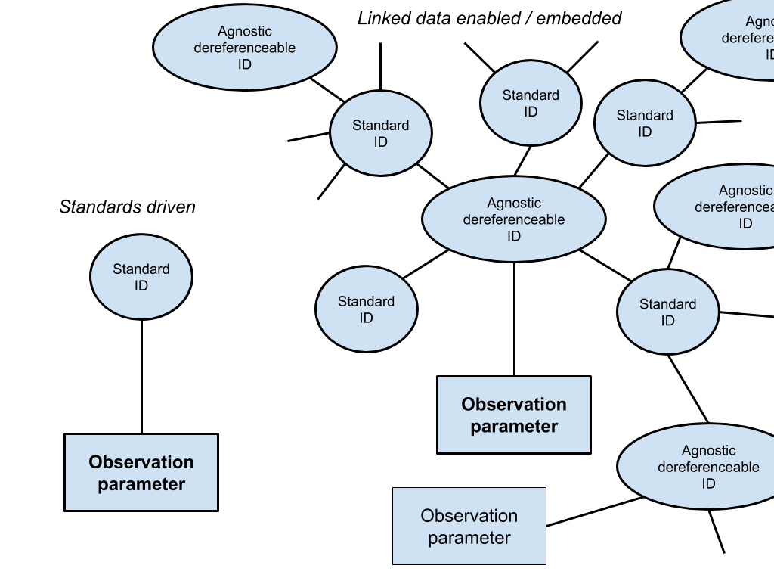When a concept is being instantiated by observations, it is critical that it is assigned a dereferenceable unique identifier that is semantically neutral. This allows the owner of the unique concept ID to document the original context of the observation, and do so without compromising subsequent enrichment/evolution by others, including by AI engines. This is the AAA principle - “anyone can say anything about anything” driving semantics as linked data. This is discussed in the three references listed above and is illustrated in the fig. It is also the principle driving modern data exchange catalogs backed by search engines, such as [schema.org](https://schema.org/). It is also the strength of “run-away” standards (AAA user-driven) such as [Gene Ontology](http://geneontology.org) (Genomics), [Loinc](https://loinc.org/) (Pathology), and [FHIR](https://hl7.org/fhir/2018Jan/linked-data-module.html) (Health Care). In that sense, Linked data expands, scales and loosens the standards-driven approach. It is an update, not a replacement. It is much easier to use, serialize and track, as illustrated in [json-ld.org](https://json-ld.org/). So how does one start? Simply by creating a JSON (LD) document in a (versioned) github repository with an agnostic (random, incremental, etc) dereferenceable, unique ID. Something as simple as [this](https://episphere.github.io/dashboard/connectFrog.json) (silly) or [this](https://public.api.researchallofus.org/v1/databrowser/survey-questions?survey_concept_id=1586134&search_word=gender) (All-of-Us).

1. <https://www.cs.rpi.edu/~hendler/LittleSemanticsWeb.html>
2. <https://www.amazon.com/Semantic-Web-Working-Ontologist-Effective-dp-0123859654>
3. [https://science.sciencemag.org/content/313/5788/769.full](https://science.sciencemag.org/content/313/5788/769.full?sid=01a86fce-f2a2-4f96-b499-44e58ae5f225)